***CASE STUDY: Car rental***

Car rental companies own a number of cars and a number of sites where cars are parked when not in use. Customers rent cars for a period of time (having made a reservation, or not) and return them.

We focus on company CARS.

The current process (AS IS), is as follows.

A customer may reserve a car, using the company web site, or the call center (this step is optional).

A customer steps into the office close to the rental car parking site and completes the first step of the *check out*. The contract for the rental is defined (period of rental, name of driver, related ID document and driving license, insurances, damage deposit, partial and total fees, credit card), signed by both parties, and the payment for the rental is completed (payment has two parts, rental and damage deposit – the latter is normally returned at the end of the rental). Further, a specific car (identified by its tag) is assigned to the rental.

Then the customer walks to the car parking site. Here the second part of the check out happens.

An employee checks with the customer the car and lists all visible damages on the car in an annex to the contract. Also this annex is signed by both parties. Then the employee hands the car to the customer (this of course includes the keys) and the rental starts.

The final step is *check in*. The customer drives the car to parking site. An employee receives the car and the keys, checks with the customer for new damages. If there are damages another process starts (we leave this process out of this analysis). At this point the rental ends. The company issues an invoice and possibly returns the damage deposit to the customer.

TO BE process.

The idea is to improve the process by introducing the same innovations used by car sharing companies.

A customer has first to define an account with CARS. In this step the customer uploads his documents (ID, driving license) and a credit card. If all is right CARS approves and the customer can later rent cars. This step can be performed on a PC or smart phone. In any case the customer has to install the CARS app on her smartphone.

When a registered customer wants to rent a car she has to do a reservation (via app or PC).

Check out works as follows. The customer walks directly to the rental car parking, via the app she signals that she wants to start the rental. The app answers with position and tag of the assigned car.

When the customer is close to the car she asks, via the app, to open the car. The system opens the car (the car needs to be modified via a device connected to the cellular network and capable of controlling some car functions, like door open/close). The keys are inside the car. The customer starts the car, and the rental.

The check in is similar. The customer parks the car in the rental car parking, stops the car, exits, and asks the app to close the car. At this point the rental is over.

Invoicing and payments proceed through the credit card.

Damage deposits and possibly damage reimboursements are avoided, introducing by default an insurance to cover all.

*LAB 1*

1. *Define the organizational model for the AS IS situation. Use a textual hierarchical representation like the following*

*Organization 1*

*Role or Organizational unit 1*

*Role or Organizational unit 2*

*Organization 2*

*…*

1. *Define the process model. Use the tabular format first (for each process: name, input, output, main organizational roles involved, description), then the BPMN. The process model must be consistent with the other models (conceptual data model, organizational model). If needed, change the other models.  
   Define the process model for the AS IS situation*

# A -- AS IS

## 1 Organizational model

In yellow the parts as described in the text above. Other parts are assumed considering a large rental company (at least active at country level, with many local agencies)

Besides the rental company (where is our focus), customer and payment circuits are listed since they interact with rental company.

Car rental company

Accounting

Finance

Human resources

IT area (manage web site and all IT services, manages call centers too?)

Legal department

Sales and marketing (will implement reservations)

Reservation office

Customer assistance (accidents, complaints..)

Car management (“manufacturing”)

Local agency (repeated many times, in each city, airport, railway station..)

(geo structure)

Office

Parking site

Maintenance (cleaning, small repairs) (full maintenance is outsourced to external

workshops)

Purchase office (for cars)

Customer

Payment circuit (credit card , bank circuit)

## 2 Process

|  |  |  |  |  |
| --- | --- | --- | --- | --- |
| Process name | In | out | description | OU involved |
| Reservation | Customer decides to reserve | Reservation complete | Customer enters her data + car requested, dates, place; makes payment | Customer + reservation office + payment circuit |
| Check out | Customer requests car (having reservation or not) | Rental started | Customer gives id, driving licence, credit card, signs rental agreement, pays damage deposit, start rental | Local agency, customer, payment circuit |
| Check in | Customer returns car | Rental ended | Damage check, return deposit, close rental | Local agency, customer, payment circuit |

The 3 processes above are in fact part of a larger process (from reservation to end of rental). Modeling 3 processes instead of a single (big) one has the advantage of splitting the large model in 3 smaller ones. Furthermore, the three processes happen in 3 very well separated moments in time (ex reservation today, checkout in 2 months, checkin a week after checkout).

### Reservation

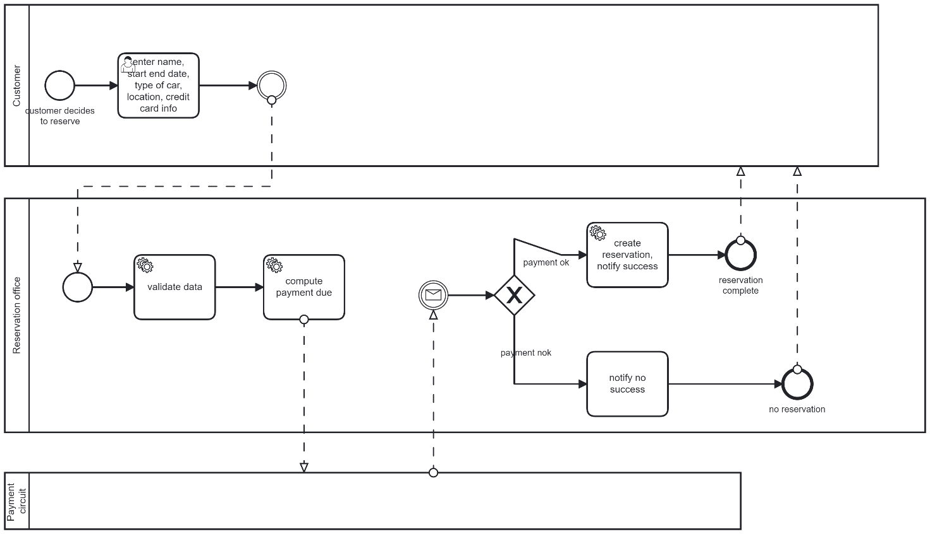

### Checkout

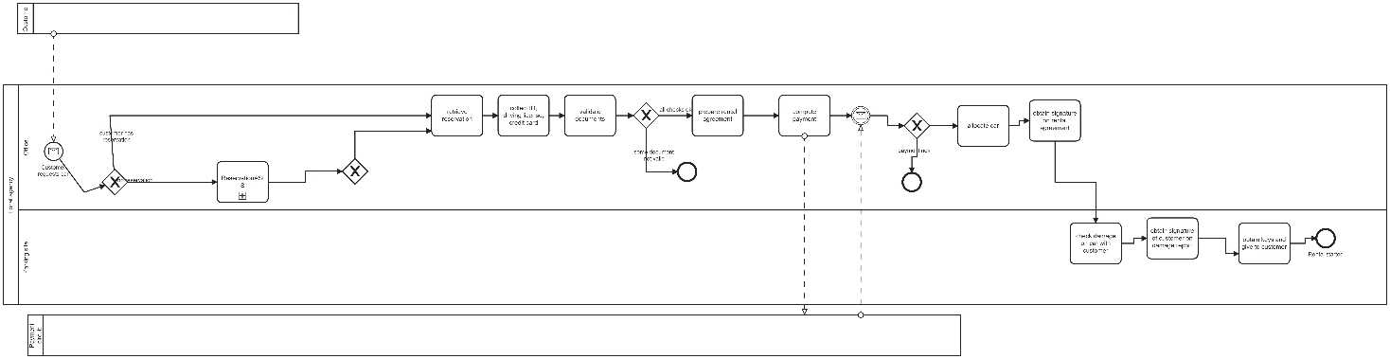

## 3 Data

Rental, rental agreement, reservation, payments, damage report

# B -- TO BE

ASSUMPTION: possible small damages to car are covered by insurance, insurance is mandatory and included in rental fee

(other options: pictures of car before and after rental, and computer vision tools to recognize damage, damage is paid by customer)

CHANGE TYPE: since the organization changes (and quite radically), this change is of second order.

## 1 Organizational model

Car rental company

Accounting

Finance

Human resources

IT area (manage web site and all IT services)

Legal department

Sales and marketing (will implement reservations)

Reservation office

Customer assistance (accidents, ..)

Car management (“manufacturing”)

**Car remote control (ADDED)**

Local agency (repeated many times, in each city, airport, railway station..)

(geo structure)

**~~Office (CANCELED)~~**

Parking site

Maintenance (cleaning, small repairs) (full maintenance is outsourced to external

workshops)

Purchase office (for cars)

Customer

Payment circuit (credit card , bank circuit)

In the new organization the office part of the local agency is canceled, since damage check and car key delivery are also avoided. Car damage is managed through insurance (see above), keys are not used anymore, the cars are open/closed via remote control. As a consequence the related infrastructure has to be put in place (Car remote control OU). Car remote control works for all local agencies.

## 2 Process

|  |  |  |  |  |
| --- | --- | --- | --- | --- |
| Process name | In | out | description | OU involved |
| Onboarding |  | Registered customer | Customer defines and account with CARS, enters driving license, ID, credit card. CARS validates everything, creates account for customer, defines fees, collects signature on agreement | Reservation office, customer, payment circuit |
| Reservation |  | Reservation complete | Customer enters his account, selects location, dates, type of car | Reservation office, customer |
| Checkout |  | Rental started | Allocate car, open car | Customer, Car remote control, |
| Checkin |  | Rental ended | Return car, close it, define payment | Customer, Car remote control  payment circuit |
|  |  |  |  |  |

We need to introduce a new process, onboarding, where a customer defines an account and inserts all her relevant documents (ID, license, credit card), so to avoid this part in the checkout process.

### Onboarding

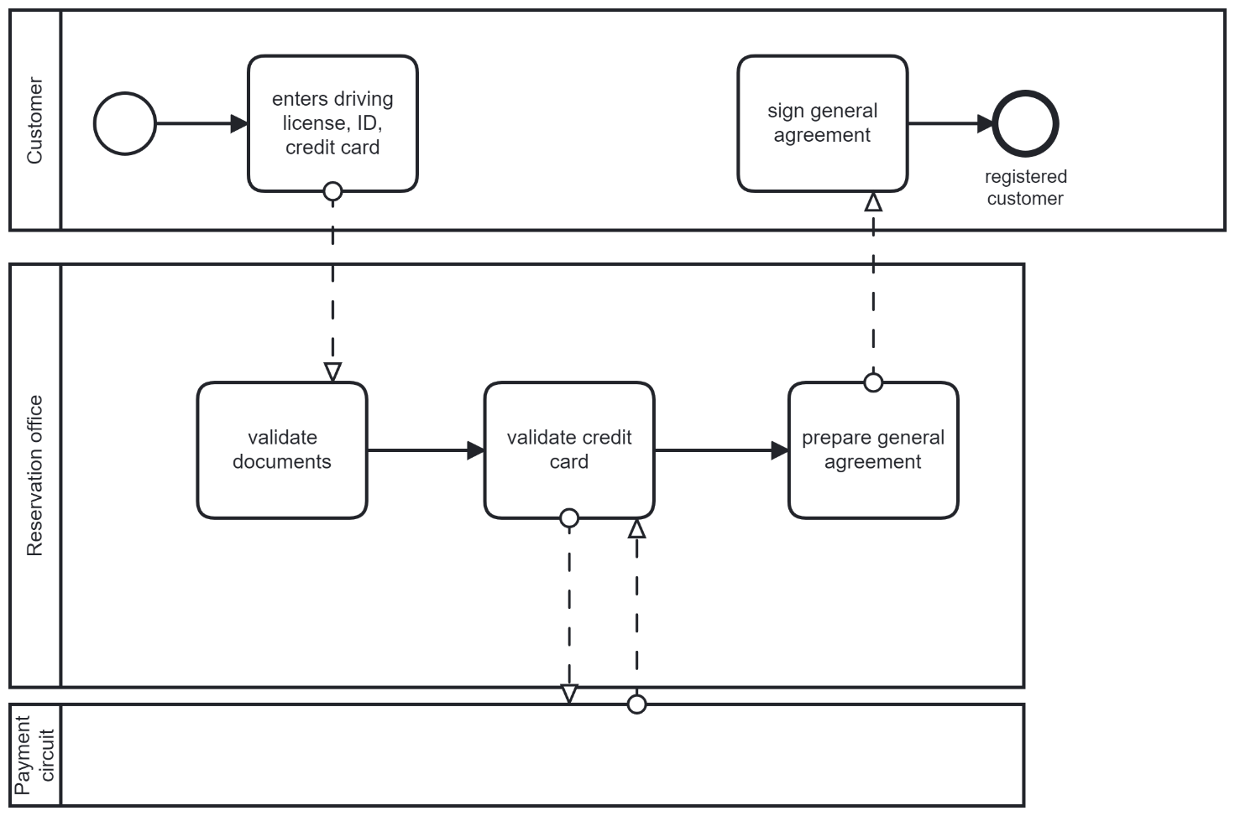

### Checkout

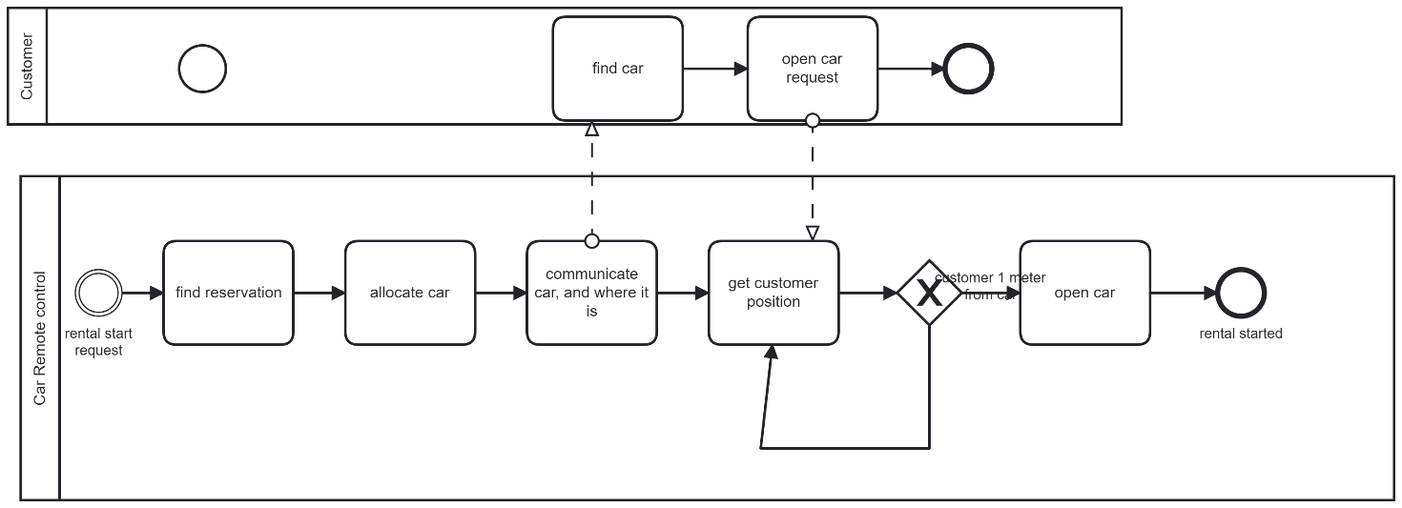

## 3 Data

Rental, customer account , general agreement, payment